The Code Breaker Documentation
Antony Gibson – ang80@aber.ac.uk CS12320
Date:

Contents

Contents Page | Page 1
Introduction | Page 2
Design | Page 3
Testing | Page 4
Evaluation | Page 5
Appendix | Page 6
Introduction

Needs a description of what is to follow, a sentence to describe how far you got with the assignment.

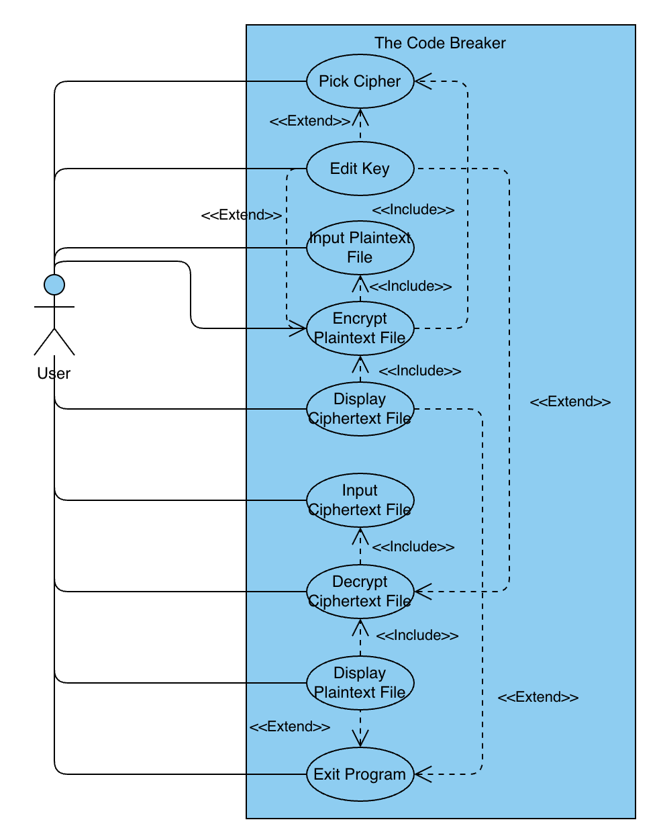
Use Case | Actor (who does it) | Outcome/Goal
Pick Cipher | User | User chooses which of the 3 available ciphers is used to encrypt the plaintext that they have inputted.
Edit Key | User | User changes the key that is used as a part of the cipher to encrypt their plaintext.
Input Plaintext File | User | User inputs a plaintext file into the program to be encrypted.
Input Ciphertext File | User | User inputs an already-encrypted ciphertext file into the program to be decrypted.
Encrypt Plaintext File | User | Previously inputted plaintext file is encrypted using the User’s chosen cipher and key.
Decrypt Ciphertext File | User | Previously inputted ciphertext file is decrypted by the program back into plaintext.
Display Ciphertext File | User | Display the ciphertext of the inputted plaintext file to the user.
Display Plaintext File | User | Display the plaintext of the inputted ciphertext file to the user.
Exit Program | User | The user chooses to end the program, multiple exit codes used to determine whether exit was an error or user choice.

Base Use Case | Relationship | Other Use Cases | Condition (if <<extend>>)
Encrypt Plaintext File | <<include>> | Pick Cipher | -
Encrypt Plaintext File | <<include>> | Input Plaintext File | -
Display Ciphertext File | <<include>> | Encrypt Plaintext File | -
Decrypt Ciphertext File | <<include>> | Input Ciphertext File | -
Display Plaintext File | <<include>> | Decrypt Ciphertext File | -
Pick Cipher | <<extend>> | Edit Key | User chooses to modify key
Encrypt Plaintext File | <<extend>> | Edit Key | User edits key before encryption
Decrypt Ciphertext File | <<extend>> | Edit Key | User edits key before decryption
Exit Program | <<extend>> | Display Ciphertext File | User can view ciphertext before exiting
Exit Program | <<extend>> | Display Plaintext File | User can view plaintext before exiting

Design

Needs a class diagram, a textual description and rationale for each class and its relationships (?? what)

Program Exit Codes:
0 – User chose to close the program
1 – Error forced closure of the program

Testing

Needs a test table (an example in the example doc given on blackboard), screenshots of running program, a screenshot for each requirement that you have implemented with a caption to describe what the screenshot is showing. Needs a discussion of the test data used and the results of running the tests (i.e. why a specific data input, whether correct or incorrect for its field, was used). Apparently needs to show program running from the command-line (?? Dunno if will work when in onedrive)

Evaluation

Discuss how assignment was solved: the order, how and why you did what you did. Was there any flair attempted? If so, describe.

What was difficult? What remains to be done? What did you learn? Answer all of these. MUST BE STRUCTURED ACCORDING TO THE MARKING MATRIX

Appendix

Describe the progression at each of the specified timepoints when uploaded to gitlab.

THIS SECTION DOES NOT COUNT TOWARDS TOTAL WORDCOUNT – wordcount excludes cover page, diagram titles, any tables used and the appendix.
TOTAL WORDCOUNT ALLOWED: 2000 (+/- 10%, so 1800-2200 words)

SAVE THIS DOCUMENT IN FINAL FORM AS A PDF, add into folder and then zip the folder and name as specified on the bottom of page 4 of the assignment brief.

Use Case Tables and Diagrams:
Version 1:
Use Case | Actor (who does it) | Outcome/Goal
Pick Cipher | User | User chooses which of the 3 available ciphers is used to encrypt the plaintext that they have inputted.
Edit Key | User | User changes the key that is used as a part of the cipher to encrypt their plaintext.
Input Plaintext File | User | User inputs a plaintext file into the program to be encrypted.
Encrypt Plaintext File | User | Previously inputted plaintext file is encrypted using the User’s chosen cipher and key.
Display Ciphertext File | User | Display the ciphertext of the inputted plaintext file to the user.
Exit Program | User | The user chooses to end the program, multiple exit codes used to determine whether exit was an error or user choice.

Base Use Case | Relationship | Other Use Case | Condition (if <<extend>>)
Encrypt Plaintext File | <<include>> | Pick Cipher | -
Encrypt Plaintext File | <<include>> | Input Plaintext File | -
Display Ciphertext File | <<include>> | Encrypt Plaintext File | -
Edit Key | <<extend>> | Pick Cipher | Only occurs if user chooses to modify the key.
Exit Program | <<extend>> | Display Ciphertext File | User can view output before exiting.

